(Approx. 767 words)

What You Need to Know about QR Codes
By Sandy Berger, CompuKISS
www.compukiss.com
sandy (at) compukiss.com

If you've seen QR or Quick Response Codes, but don't know what they mean, this article will explain it all for you. QR codes are becoming more and more prevalent and offer additional information on many of the things you read and see. QR codes can be found in many current magazines and newspapers.

QR codes: They are small squares filled with black square dots arranged in a grid pattern on a white background. If you look carefully at a QR code, you will see that each one is unique in the placement of the small black and white squares. While this doesn’t mean anything to the eye of the beholder, the placement of the dots defines the additional data that is embedded in the code. The QR code on the left will lead you to The website of The Pilot, a newspaper I write for. The one on the right will lead you to the home page on my Compu-KISS website.
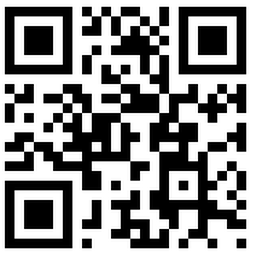
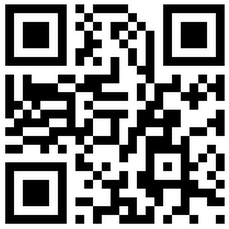

Although most QR codes are black and white, they can also contain stars, squares, and other color and/or black and white images.

QR codes are now linking paper content like newspapers and magazines to digital content. To understand QR codes, you can think of them as paper-based hyperlinks that work like bar codes. To access the digital content, you need a QR reader which you can easily download to your smart phone or tablet. Most of these are free. They use the camera in your phone to read the QR code and take you to the digital content.

You can find a QR code on a newspaper or magazine article, a business card, or a menu. Actually QR codes can be printed on just about anything. I’ve even seen them printed on T-shirts. Of course, they can also be used digitally. For example a QR code could be displayed on a web page to transfer information directly to a cell phone. A QR code can even be added to a Tweet.

To access the information in a QR code, after you download a free QR reader, you simply start the app and hold your mobile phone or tablet about 4” to 6” with the camera squarely above the QR code. When you get it positioned properly, you phone will take the picture and display the additional information on your device. You don’t have to press any buttons or the screen, everything is done automatically.

QR codes can give you many different types of additional information. If you see one on an advertisement, it will probably lead you to more information about the product. A QR code on a business card can lead you to more information about that person or company. QR codes can lead you to things like coupons, movie trailers, phone numbers, or directions. I find them invaluable when on a recipe because they allow me to view the recipe on a tablet and use it immediately in the kitchen.

Several companies have developed further enhancements for QR codes allowing them to hidden in a picture. They embed imperceptible digital information in pictures or behind text, creating an invisible hyperlink to online content. They can even embed a QR code in an audio file.

Digimarc is a company in the forefront of the QR world. I use the free Digimarc app because it works with their own “hidden” codes as well as regular QR codes and barcodes. It is available for both Android and Apple.

When a QR code is hidden, there will usually be a note to that effect or a small logo on or near the picture to indicate that it is, in fact, a QR code. Even though you don’t see the code, you can hold your phone or tablet over the picture to activate the code.

QR codes are very popular in Japan and are becoming more and more popular here as people find new uses for them. I imagine that sometime soon, all smart phones and tablets will come with a QR code reader so you won’t have to download one.

If you are interested in creating a QR code for your T-shirt, business card, or website, the easiest way to do it is to use a third-party QR code generator. I created the two QR codes shown in this article using a website called Kaywa at http://qrcode.kaywa.comhttp://qrcode.kaywa.com. Of course, Kaywa has professional options that you have to pay for, but creating a few simple QR codes is completely free.

